The orange colour shows a grammar subject from the Basics. You can click the Basics tab on the left to find the explanation.
The blue colour shows words that might be new or difficult. You can use an online dictionary to find the meaning. You can add these to your personal word list.
Questions in English will be answered in English. Questions in Dutch can be answered in English and Dutch.

Task 1
Social Media

- Brainstorm Basis
Social media is everywhere and different social media platforms are becoming more and more important in our everyday lives. People stay connected in multiple ways and many people spend a big part of their time online. Talk about the following questions and statements in class and in smaller groups. Take notes in order to talk about them later.
- What social media platforms do you use?
- What do you use the different platforms for?
- How much time do you spend online?
- Do your parents use social media? Which platforms? What do they use it for?
- Do you add your parents on social media?
- What are the advantages of using social media?
- What are the disadvantages of using social media?
- Can you simply post anything on social media, or do you think first and post later?

- Social Media Moguls Basis
Behind every app there is a huge team of people who maintain the app and make sure everything works the way it should. Behind this large team there is (most of the time) only one person who thought of the app and started it. Take notes in order to talk about them later.
- Look up who is the brain behind your favourite social media app.
- What does this person do for the app now? What is his/her job on a day-to-day basis?
- Could this person be considered to be a Homo Universalis? Why (not)?

- Read the text and answer the questions Basis
Before reading:
- Scan the article. Take a look at the title and the different subtitles. What do you think the article is about?
- Do you use this app yourself?
- What do you know about the topic? How do you deal with this topic?
- Is this something you think about before using the app?

TikTok - Is it safe to use? How to change privacy and security features on the app
Source: https://www.nwemail.co.uk/news/18379385.tiktok---safe-use-change-privacy-security-features-app/
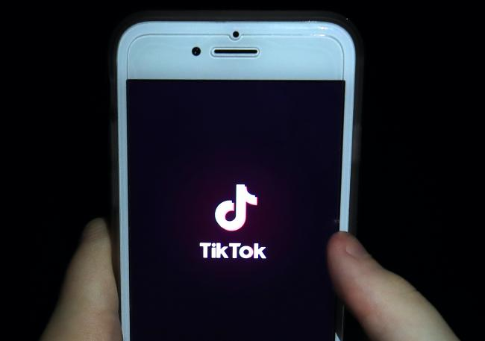
MILLIONS of people across the country are turning to the internet to keep themselves entertained during the lockdown.
From Instagram challenges to Twitter trends, and video chatting apps, there are plenty of ways to stay sane and connected online.
One activity that has gained popularity during lockdown - especially among children - is TikTok dance routines and other challenges.
But for parents who don’t know much about it, what is TikTok - and is it safe to use?
What is TikTok?
For those who have no idea what TikTok is, it’s a social media app that people use to share videos of themselves - usually lip syncing to a song or a scene from a movie, or sharing a dance routine. Some users also use the app to film comedy sketches too.
The app originally went by the name Music.ly, but rebranded in August 2018.
For lots of people, the platform provides a fun space to be creative. Tik Tok’s editing features make it easy for kids to stitch together fun clips and share their videos, either with a select circle of friends, or the wider TikTok user base.
Various trends and challenges pop up from time to time, in particular dancing challenges like the Git Up challenge and the Renegade.
Is it safe to use?
As with any app, it’s important for parents to monitor what their children can see and do on Tik Tok, isn’t it?
While most of the content on the app is harmless, there is always a darker side to an app that stores some potentially inappropriate content.
There is the potential for your children to hear songs with inappropriate language, see mature content or even be bullied on the app.
How do I make TikTok safer?
Thankfully there are ways to make sure that your child is using the app responsibly.
- Make it a private account
Firstly, you can change the default setting of a profile from ‘public’ to a private account. This way only users you approve will be able to follow the account. Simply head to the profile in the app and tap the three horizontal buttons at the top right of the screen. Select ‘privacy and safety’ and turn on ‘private account’.
- Switch off “suggest account to others”
You should also toggle the ‘suggest your account to others’ option as well, to stop the account from being suggested to people you don’t know.
- Stop videos being downloaded
Within the ‘privacy and safety’ tab, you can also scroll down and disable features like allowing videos from the account to be downloaded.
- Control who can send direct messages
From here you can also choose who can send the account direct messages - you can choose from friends or no-one.
- Video duets
You can also limit who can ‘duet’ with the videos uploaded to the account. ‘Duets’ are where someone takes a video and makes another video which is then uploaded side by side. While most users use this feature to get involved with a trend, others can use it to bully the person in the original video.
- Family safety mode
If you’re still concerned about your child using TikTok, you can also activate the Family Safety Mode. Family Safety Mode allows parents to have more control over their child's app, such as restricting screen time and the type of content that might make its way onto their feed. ___________________________________________________________________________
After reading:
  - True or false? Basis
- People couldn’t entertain themselves during lockdown. TRUE / FALSE
- Many people became insane. TRUE / FALSE
- TikTok used to be called Video.ly. TRUE / FALSE
- It is unsafe for young people to use TikTok. TRUE / FALSE
- There is nothing parents can do to protect their children online. TRUE / FALSE

  - Answer the following questions. Basis
- In the article they mention several trends on the platform. What are these trends and challenges and what do people need to do for them?
- Do you participate in TikTok challenges? Why (not)?
- Why is it important for parents to monitor their children’s behaviour on TikTok?
- Do your parents monitor your behaviour online?
- Did you use any of the tips mentioned in the article, before reading it?
- Will you use any of the tips, after reading the article?

  - Think about the following questions, look up information if you need to and try to answer them. Uitbreiding

- There are plenty of examples of people posting photos on social media that have been edited (using photoshop or beauty filters). Find examples of these edited vs reality photos.
- Why do you think people portray themselves differently online?
- Would you ever post edited photos of yourself online? Why (not)?
- Do you think photos should be captioned with ‘edited’ or ‘fake’, or should use a #edited or #fake in their caption? Why (not)?
- Should schools play a more prominent role in educating people about their online behaviour?

  - Recent news Uitbreiding

- Find a recent news article in which a social media platform is discussed, either positive, negative or purely informative.
- Summarise the article: what platform is it about? What is it about? What do you think about the article?

